Adaptations 2: Plant Adaptation Card Game Middle School Scientists Curriculum

Class Time Required:
1 class period (50-65 minutes)
Extension (30-45 minutes)

Materials Needed:

- Engagement: Different Types of Plants or Pictures of Plants, Biomes on Earth Diagram
- Investigation and Explanation: Attachment 1, “Adaptations 2: Plant Adaptation Card Game” (Plant adaptations cards -enough sets for one set per 2-3 students), Worksheet 1, “Adaptations 2: Plant Adaptation Card Game”
- Extension: Research Materials (books, textbooks, internet), Materials to Make Collage

Teacher Preparation: 1- 1 ½ hours to make cards for game; 30-60 minutes to review activity, collect materials, and make copies

Student Knowledge: Basic understanding of the term “adaptation,” ability to give examples of adaptations in common plants, research skills

Vocabulary: adaptation, biome, gymnosperm (optional), angiosperm (optional)

Next Generation Science Standards:
- MS-LS1-4.
Use argument based on empirical evidence and scientific reasoning to support an explanation for how characteristic animal behaviors and specialized plant structures affect the probability of successful reproduction of animals and plants respectively.

MS-LS1-5.
Construct a scientific explanation based on evidence for how environmental and genetic factors influence the growth of organisms

Overview:
After an introduction to plant adaptations and different biomes on Earth, students will play a card game that examines adaptations of plants from six different biomes: tundra, taiga, desert, grassland, deciduous forest, and tropical rainforest. By playing the card game and filling out the worksheet, students reinforce the concepts of different adaptations by different plants to ensure survival. The extension activity allows students to pick a biome that is individually interesting and make a collage of pictures about that biome, using pictures cut from magazines, or create a collage online using resources from the internet.

Background Information:
Plants are the basis of food webs on the Earth’s landmasses. Adaptations of plants through time have allowed survival of individual plants or species that change in response to changes in their environments. Plants have to adapt to survive in their particular environment because they must compete for limited space and nutrients, and must be able to ward off or survive herbivory. Plants must have adaptations that allow them to absorb and retain water and nutrients, sunlight for photosynthesis, and the ability to carry out gas exchange (Miller, 2010).

Vascular plants can be grouped into two broad categories that include most species: angiosperms and gymnosperms. Gymnosperms are defined as a vascular plant that reproduces with a “naked seed” such as a cone. As a group, gymnosperms include many trees including spruces, firs, pines, junipers, and cedars. Many of these plants are considered “evergreen” which means they retain their leaves year round. The leaves of gymnosperms are “needle-shaped” to help conserve moisture. Many have a waxy coating to further prevent water loss. Trees are spire shaped to reduce damage from snowfalls. (“Angiosperms”, 2014)

Angiosperms are vascular plants that reproduce by flowering and producing enclosed seeds. They have evolved several very efficient ways of seed dispersal. Many of the trees that are common in urban areas are angiosperms, including oaks, maples, many shrubs. “Deciduous” is a term used to describe trees that lose their leaves seasonally. Most angiosperms are deciduous. Their leaves are usually thin and broad, creating a large surface area for photosynthesis to occur. Their bark is often thick in order to provide protection from environmental factors and predators. (“Angiosperms”, 2014)

Focus Questions:
What adaptations do plants have that help them survive? How can plants survive in so many different environments?
How can the same adaptation allow plants to survive in different types of biomes?

Learning Target:
I can name a specific biome and describe different plant adaptations that help with survival in that environment.

Engagement:
(10-15 minutes)
The instructor will bring different types of plants into the classroom for students to observe. The instructor should try to bring in a diverse group of plants that are representative of different biomes. If plants are not available, the instructor can provide pictures for groups of students to serve the same purpose. The instructor will ask students how the plants are similar and how are they different.

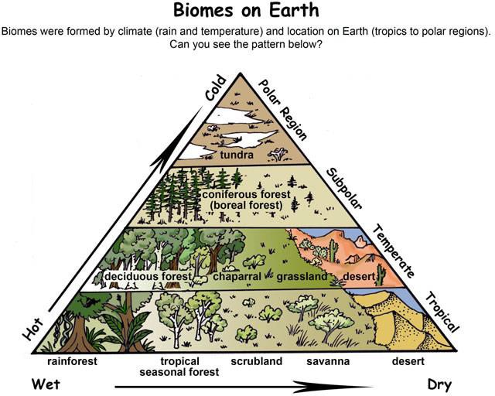
What is a biome? The instructor will show a diagram of the different biomes that illustrates the relationship between biomes, temperature, and precipitation.
The instructor will help students to understand that different biomes are influenced by temperature, rainfall, and location on Earth.
The instructor will ask students for input in matching the different plants or pictures to the correct biome in the diagram and ask students how the plant is adapted to survive in that environment.

Investigation:
(25-30 minutes)
The instructor will explain that students will be playing a plant adaptation game which requires them to collect sets of cards that pertain to plants found within a particular biome. The card set will show specific adaptations of different plants that help them survive in that biome (“Missouri”, 2014).

Rules of the Plant Adaptation Game (Played between two students)

- The students will shuffle cards and deal each player eight cards. The rest of the cards are placed in a stack face down in the middle of the table, with one card face up to start the game.
- Each player looks at his/her cards. The goal is to collect all four cards from two different biomes.
- The first player can choose the card that is face up on the table or draw one card from the deck and put in his/her hand. The player will then select one card to discard and will place it face-up by the pile of cards that are face-down.
- The next player can choose the previously discarded face-up card on the table or draw a new card from the face-down stack.
- Play continues until a player has collected all four cards from two different biomes.
- When a student wins a game, the instructor may wish to quiz the student about his/her winning biome and its plant adaptations for a small prize.

Explanation:
(15-20 minutes)

Students will fill in information about plant adaptations in each biome and answer questions on Worksheet 1, “Adaptations 2: Plant Adaptation Card Game” about different plant adaptations.

Extension:
(30-45 minutes)
Students will make a collage of plants found in a particular biome from magazines or using pictures from the internet. Students will show and label different plant adaptations. They must include the name of the biome and three pieces of information about the biome.

References:
"Angiosperms vs Gymnosperms." Diffen.com. Diffen LLC, n.d. Web. 4 Sep 2014. <
<http://www.diffen.com/difference/Angiosperms_vs_Gymnosperms >

Biome Pyramid Diagram:
Amsel, Sheri. “Glossary (What Words Mean) with Pictures!.” Biome. Exploring Nature Educational Resource. © 2005 - 2014. June 16, 2014.
<http://exploringnature.org/db/detail.php?dbID=13&detID=281> Klass, Mary. “Plant Card Photographs.” 2014. JPEG file.
Miller, Kenneth R., and Joseph S. Levine. "22 Introduction to Plants." Miller & Levine Biology. Boston, MA: Pearson, 2010. 632-49. Print.

"Missouri Botanical Garden." Missouri Botanical Garden. Ed. Elizabeth Schwartz, PhD. The Evergreen Project, 2009. Web. 15 June 2014.
<http://www.mbgnet.net/bioplants/adapt.html>

